1. Run npm config set proxy <http://proxy.company.com:8080>” under nodejs folder after installing nodejs.
2. This command generates a file “.npmrc “ under C:\Users\144073\
3. 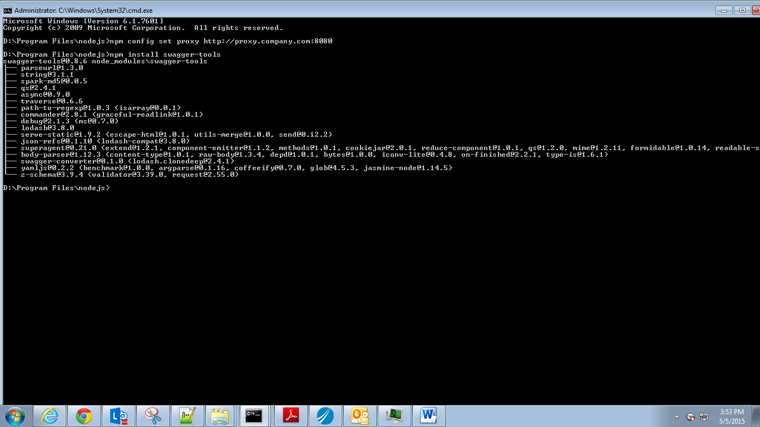
4. Edit that file inside and enter the following lines in it .

proxy=http://144073:<<*account_pwd*>>@proxy.cognizant.com:6050

https-proxy=https://proxy.cognizant.com:6050/

strict-ssl=false

registry=http://registry.npmjs.org/

1. Run “npm install swagger-tools” command. That installs npm successfully.

Steps to validate json.

1. Copy docs.json and the other jsons to “D:\Program Files\nodejs\node_modules\.bin” location.
2. Run the command “swagger-tools validate docs.json VRS_APISpec.json” from “D:\Program Files\nodejs\node_modules\.bin” location.
3. Error & Fixes :
   1. Err : Missing required property: method

Fix : ReplaceAll “HttpMethod” to “method”

* 1. Err : Expected type integer but found type string

Fix: Remove all quotes from numbers eg: Replace “200” as 200 (without quotes).

* 1. Err: Expected type string but found type null

Fix : Delete the lines that has “null” – if its not of any importance.

* 1. Err: Missing required property: name

Fix : Add a field called “name” under parameters as shown below. Value for this field can be any string.

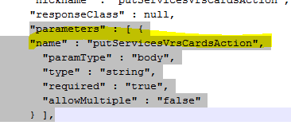

* 1. Err: Expected type boolean but found type string

Fix: Replace all “true” and “false” to true and false (without quotes)

* 1. Err:

#/apis/3/operations/1: Data does not match any schemas from 'oneOf'

#/apis/3/operations/1: Missing required property: type

#/apis/3/operations/1: Missing required property: $ref

Fix : Add a field call “type” under nickname field. As shown.

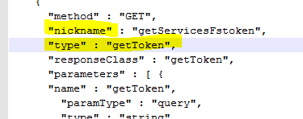

* 1. Err: API requires path parameter but it is not defined: partner

Fix : This is because there is no definition of {partner} field defined in path "path" : "/fs/v1/{partner}/transactions/vrs/". By adding the definition of this under “parameters” will fix the error. Eg shown below

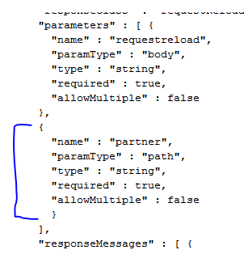

* 1. Err: Model could not be resolved: merchantFilter

Fix: Name defined under models should match “type” defined in operations

**Operations Models**

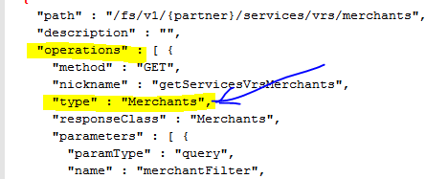 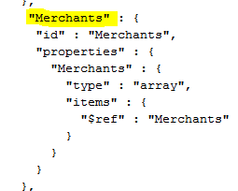

Fix2 : If there is no models found for an operation, define a dummy model as shown below.

